**a**

**MINI PORJECt REPORT**

**ON**

**“WIRELESS SCROLLING DISPLAY”**

FOR PARTIAL FULFILLMENT

OF THE REQUIREMENTS FOR THE

Mini PROJECT and SEMINAR SUBJECT

oF T.E. E&TC – 2015 Course, SPPU, Pune

By

**Ashlesh Khajbage T150053022.**

**Aditi Dorle T150053010.**

**Akhil Rane T150053017.**

**GUIDE**

**Prof. R. Sreemathy**



**Department Of**

**Electronics and TELECommunication ENGINEERING**

**PUNE INSTITUTE OF COMPUTER TECHNOLOGY**

**PUNE – 43**

**ACADEMIC YEAR: 2018 - 2019**

**Department of Electronics and Telecommunication Engineering**

**Pune Institute of Computer Technology, Pune – 43**

**CERTIFICATE**

This is to certify that the Mini Project Report entitled

Wireless Scrolling Display

has been successfully completed by

Ashlesh Khajbage T150053022.

Aditi Dorle T150053010.

Akhil Rane T150053017.

Is a bona fide work carried out by them under the supervision of **Dr. R. Sreemathy** and it is approved for the partial fulfillment of the requirements for the Mini Project and Seminar Subject of T.E. E&TC – 2015 Course of the Savitribai Phule Pune University, Pune.

Prof. Prof.

**R. Sreemathy**   **Dr. Y. Ravinder** Dept. of E&TC HOD, E&TC

Place: Pune

Date :

ACKNOWLEDGEMENT

We express our sincere thanks to our project supervisor **Prof. Dr. R. Sreemathy**  for her kind support, encouragement and guidance throughout the course of our project work. It is because of her continuous support we were able to achieve much in this project work. We would also like to express our sincere gratitude to our project coordinator **Mr. Sutar Sir** for his guidance on this project course. Similarly we would like to thank all the teachers and lab incharges who have helped us in every possible way. This project has helped us a lot in our understanding and experience. Besides, it has been a great excitement doing this project and we hope to achieve much more in future. We, therefore look forward to your kind support in the years to come.

A special gratitude I give to our project  supervisor, **Dr. V. B. Vaijapurkar** S, whose contribution in stimulating suggestions and encouragement,  helped me to coordinate my project especially in writing this report.

My thanks and appreciations also go to my colleague in developing the project and people who have willingly helped me out with their abilities.

Ashlesh Khajbage

Aditi Dorle

Akhil Rane

**ABSTRACT**

The scrolling displays are the best noticing or messaging displays with low cost. Although there are several display available readily in market it required to design a display for local need. This project aims to design a LED display to display characters and numbers in different languages. This characters can be read from 3 m and worth hanging in huge building.

In this project we have developed LED display using 8 x 8 Led matrix using 384 led’s altogether. The developed display is capable of displaying fixed characters and rolling strings. The display is able to display English, Hindi and Marathi letters and numbers. It draws 500mA current and operates on 5V DC. It consumes total 1.6W power. The display size is 53cm in length and 11cm in height. Readability for English letter is high, however for Hindi and Marathi it takes some time in perception. In future the display can be assisted with sound and better resolution for graphical letters.

The String to be displayed on LED matrix is provided by an Android application. User can display up to 4 messages. The added features in this project include rolling speed control, more than 1 international, 1 national and 1 regional language support.

**LIST OF FIGURES**

|  |  |  |
| --- | --- | --- |
| Sr. No | Figure number and Figure caption | Page no. |
| 1. | 2.1 block diagram | 5 |
| 2 | 2.2 Flowchart | 8 |
| 3 | 3.1 Atmega microcontroller | 10 |
| 4 | 3.2 MAX7219 pin out | 11 |
| 5 | 3.3 Connection of MAX7219 and 8x8 matrix | 13 |
| 6 | 3.4 eye Response to color | 13 |
| 7 | 3.5 LED matrix | 14 |
| 8 | 3.6 Potentiometer and its symbol | 15 |
| 9 | 3.7 HC05 and HC06 | 17 |
| 10 | 3.8 LCD with pin outs | 18 |
| 11 | 4.1 8x8 matrix with 74HC595 | 20 |
| 12 | 4.2 8x8 matrix with MAX7219 | 21 |
| 13 | 4.3 Schematic of microcontroller | 22 |
| 14 | 4.4 PCB copper plated board | 22 |
| 15 | 4.5 PCB layout of microcontroller | 23 |
| 16 | 4.6 layout on PCB | 23 |
| 17 | 4.7 Etching process | 24 |
| 18 | 4.8 Drilling Process | 24 |
| 19 | 4.9 Component placing and soldering | 25 |
| 20 | 4.10 Led Matrix Schematic | 25 |
| 21 | 4.11 double side PCB for LED Matrix | 26 |
| 22 | 4.12 Driver Circuit Schematic | 26 |
| 23 | 4.13 PCB design of driver | 27 |
| 24 | 5.1 Scrolling text in English | 28 |
| 25 | 5.2 Static text in Hindi | 28 |
| 26 | 5.3 German rolling text | 29 |
| 27 | 5.4 Special character and numbers display | 29 |
| 28 | 5.5 Speed Control display | 30 |

**LIST OF TABLES**

|  |  |  |
| --- | --- | --- |
| Sr. No | Table number and Table caption | Page no. |
| 1 | 3.1 Comparison of different microcontroller | 9 |
| 2 | 3.2 Comparison of max3719 and 74HC595 | 11 |
| 3 | 3.3 Selection of Iset Resistor | 12 |
| 4 | 3.4 Comparison of Potentiometer and Rheostat | 15 |
| 5 | 3.5 HC-05 vs. HC-06 | 16 |
| 6 | 3.6 ranges of Bluetooth devices | 17 |
| 7 | 3.7 Selection of components and justification | 19 |

**SYMBOLS AND ABBREVIATIONS**

**A. Symbols**

**Symbol Description**

Ω Ohm

KΩ Kilo ohm

μs Micro second

mA Milli ampere

**B. Abbreviations**

**Abbreviation Full Form**

LED Light Emitting Diodes

LCD Liquid Crystal Display

IC Integrated Circuit

ASCII American Standard Code for Information Interchange

PCB Printed Circuit Board

**TABLE OF CONTENTS**

|  |  |  |  |  |
| --- | --- | --- | --- | --- |
|  | Abstract | | | i |
|  | List of Figures | | | ii |
|  | List of Tables | | | iii |
|  | Abbreviations | | | iv |
|  |  | | |  |
| 1 | Introduction | | | 1-4 |
|  | 1.1 | Back ground and Context | | 1 |
|  | 1.2 | Relevance | | 2 |
|  | 1.3 | Literature Survey | | 2 |
|  | 1.4 | Motivation | | 3 |
|  | 1.5 | Aim of the Project | | 3 |
|  | 1.6 | Objectives and Scope | | 4 |
|  | 1.7 | Technical Approach | | 4 |
|  |  |  | |  |
| 2 | Block Diagram | | | 5-8 |
|  | 2.1 | Block diagram | | 5 |
|  | 2.2 | Theoretical background | | 5 |
|  | 2.3 | Algorithm | | 7 |
|  | 2.4 | Flowchart | | 8 |
|  |  |  | |  |
| 3 | System Design | | | 9-19 |
|  | 3.1 | Design of Blocks | |  |
|  |  | 3.1.1 | Selection of microcontroller | 9 |
|  |  | 3.1.2 | Seletion of led matrix driver | 11 |
|  |  | 3.1.3 | Selection of LEDs | 13 |
|  |  | 3.1.4 | Selection of Speed Control | 15 |
|  |  | 3.1.5 | Selection of Bluetooth Module | 16 |
|  |  | 3.1.6 | LCD 16x2 | 17 |
|  | 3.2 | Selection of components and justification | | 18 |
|  |  |  | |  |
| 4 | Implementation, Testing and Debugging | | | 20-27 |
|  | 4.1 | LED blinking using 74HC595 | | 20 |
|  | 4.2 | 8x8 led matrix with MAX7219 | | 21 |
|  | 4.3 | PCB design layout | | 22-27 |
|  |  | 4.3.1 | Arduino Controller Board | 22 |
|  |  | 4.3.2 | 48x8 LED Matrix | 25 |
|  |  | 4.3.3 | LED Matrix Driver | 26 |
|  | 4.4 | Testing and troubleshooting | | 27 |
|  |  |  | |  |
| 5 | Results and discussion | | | 28-30 |
|  | 5.1 | Scrolling text in English | | 28 |
|  | 5.2 | Static text in Hindi | | 28 |
|  | 5.3 | Scrolling text in German | | 29 |
|  | 5.4 | Implementing Number and special characters. | | 29 |
|  | 5.5 | Speed Control display on LCD | | 30 |
|  |  |  | |  |
| 6 | Conclusions and Future Scope | | | 31 |
|  | 6.1 | Conclusion | | 31 |
|  | 6.2 | Future scope | | 31 |
|  |  |  | |  |
| 7 | Bill of Material | | | 32 |
|  |  | | |  |
| 8 | Appendix | | | 33 |
|  | A | References | |  |
|  | B | Datasheets | |  |

**CHAPTER 1**

**INTRODUCTION**

This chapter discusses the background of the project topic. This chapter also discusses its importance and where it has begun in history. Certain objective and aim of the project are also set in this chapter.

* 1. **Background Theory and Objectives** 
     1. **Background**

Nowadays, we can see various ways of visual information everywhere. One of the most common sights that we can see today is the LED Matrix Display. Nowadays these are extensively used in streets, malls, buildings, parks and other public places. LED Matrix Displays have become a basic way of visual information since they are cheaper and more reliable than LCD displays and other expensive display devices. Now, considering the growing popularity of the LED Matrix display, we decided to construct a small home based App controlled LED Matrix display so that it could be used for small college Activites purposes as well as for various entertainment purposes. Therefore our project deals with the construction of a LED Matrix display.

The LED-matrix consists of many LEDs grouped together to form a matrix and is controlled through a control unit and a controller. This matrix mainly displays the messages pre-stored or short messages which can be instantly displayed from an interface for a certain amount of time.

* + 1. **Objectives**

This project mainly focuses on the following topics

* To study existing concepts and required materials related to a LED Matrix Display
* To design and develop proper circuit, for a LED Matrix Display.
* To create an Android App to enter data to be displayed by the LED Matrix Display.
* To implement and test for the projected results.
  1. **Relevance**

Led matrix is a dot matrix of large display, low resolution value and is useful for both industrial or commercial displays as well as for hobbyist human interface machines. It contains a 2-D diode matrix with cathode joined in rows and anode in columns. In this [LED](https://microcontrollerslab.com/led-blinking-pic16f877a-microcontroller/)matrix each can be controlled individually by controlling the current through each pair of columns or rows diodes. These matrix are very popular matrix by means of displaying information it, allows the static and animated images and text.

* 1. **Literature Survey**

During literature survey we found following report

In the paper by Adamu Murtala Zungeru1, Gbenga Daniel Obikoya2, Ochi Fortuna-tus Uche3, Taidi Eli4, they implemented a system in which they developed a GSM based scrolling Message display board in which they used two AT89C52 micro-controllers from Atmel. The controller provides all the functionality for message display board and wireless communication. The wireless communication is done using GSM in which an authorized number can change the message by just sending a SMS on the GSM board number. The system eliminates the task of manual reprogramming the controller again and again every time there is new message as in [1]. In the paper by Prachee U. Ketkar1, Kunal P. Tayade2, Akash P. Kulkarni3, RajkishorM.Tugnayat4, they implemented a GSM based scrolling message system in which they usedAT89c51 micro-controller which provide all the functionality for wireless communication. It uses a GSM modem to which a SMS is send from an authorized user it verifies the password first and then display the message on the board after verifying the password. The system also shows the method of displaying the alphabet on LED dot matrix [2].

In the paper by Anuradha Mujumdar, Vaishali Niranjane, Deepika Sagne, they implemented a wireless transmission system in which they used RF based transmission for sending the message to be displayed. The system also provides an idea of how to make the connection between the LED while connecting in matrix, the system uses 5x7 LED dot matrix to display a single character on the board. It uses 8051 micro-controllers in which the memory capacity is less so it requires an external EEPROM for storing the code and message. It papers also gives an idea of character coding [3]. In the paper by Gowrishankar Kasilingam, Mritha Ramalingam and Chandra Sekar, they proposed a system in which the introduced a concept of dual option of changing the message one by using GSM and second by using PC or Laptop. It also came up with a concept of dual power supply one through AC power and second through solar power. Such collaborative powers and method of changing message had not been developed in a single device, and this paper marks the beginning of the new technology of combining two separate technologies under one roof[4].

* 1. **Motivation**

This project was motivated by the proliferation of unprofessional matrix display seen around outside the campus of PICT. This signals a need for the design of a cheap but efficient matrix display with capabilities captured in high technology matrix systems.

* 1. **Aim Of The Project**

Design and develop 48 x 8 LED multilingual displays, bridged with help of UART communication between microcontroller and Application.

* 1. **Objectives and Scopes**

**Objectives**

* To study existing concepts and required materials related to a LED Matrix Display
* To design a proper circuit, for a LED Matrix Display, which is most suitable for our case.

* To create an Android App to enter data to be displayed by the LED Matrix Display.

**Scope**

* Ability to display scrolling text on the led matrix which will attract people to read and gain information.
* Ability to convey message/notices in other language as well.
* To be built easily and easy extension of the hardware.
  1. **Technical Approach**

This project can broadly be divided into two sections:

• **Software part:**

Software part includes programming design for the system. In this part, a C program is developed in order to send information to LED Matrix from microcontroller via the driver circuit.

• **Hardware part:**

Hardware part includes the design and construction of the hardware parts of the system. Design of LED Matrix and construction of supporting elements like development of power supply, implementation of transistors as switch and LED driving circuits are included in this portion. This Section also include the PCB designing of the above.

**CHAPTER 2**

**BLOCK DIAGRAM**

This chapter discuss about the system block diagram and brief description of the block that are appeared in the system block. This chapter also includes the algorithm and flowchart the program.

**2.1 Block Diagram**

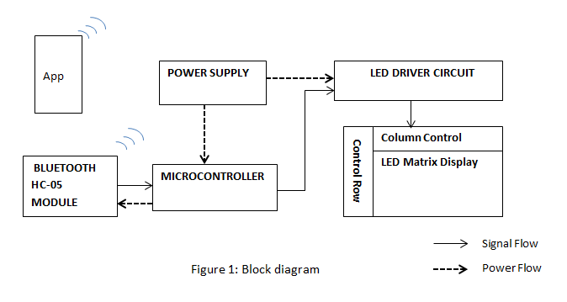

Figure 2.1

The Operational framework of the LED Matrix display is shown in Figure 1. The figure illustrates that the Microcontroller Driven driver circuit controls the rows of the matrix as well as columns. Furthermore, Microcontroller triggers the driver of the circuit and provides the sequence of data.

**2.2.1 LEDs**

As the name implies, a Light Emitting Diode (LED) is a diode that gives visible or invisible (infrared) light when energized. LEDs are diodes usually constructed by GaAs. In such semi-conductor p-n junction, during the recombination of holes and electrons, the energy is dissipated in the form of photons resulting in the emission of light.

**2.2.2 LED Matrix**

An LED matrix is a two dimensional array of LEDs that can be used to display symbols, characters or even images. Based on the orientation of the LEDs in the matrix, there can be two types of LED matrices. They are Common Row Anode and Common Row Cathode. We will using common cathode configuration.

**2.2.3 LED Driver Circuit**

The LED matrix can be driven in two ways. They are parallel (where each row or column are sent with parallel data) and serial (where the data is sent serially and an IC is used to convert this serial data into parallel data).

**2.2.4 Controller**

Controller is used to control operation of different devices and it provides required output. Controller takes the input from Bluetooth Module and display the information on LED matrix in Scrolling fashion. Android App is source where user enters information.

**2.2.5 Bluetooth**

Bluetooth is a [wireless](https://en.wikipedia.org/wiki/Wireless) technology standard for exchanging data between fixed and mobile devices over short distances using short-wavelength [UHF](https://en.wikipedia.org/wiki/UHF) wave sine the [industrial, scientific and medical radio bands](https://en.wikipedia.org/wiki/ISM_band), from 2.400 to 2.485 GHz. Bluetooth uses a radio technology called [frequency-hopping spread spectrum](https://en.wikipedia.org/wiki/Frequency-hopping_spread_spectrum). Bluetooth divides transmitted data into packets, and transmits each packet on one of 79 designated Bluetooth channels. Each channel has a bandwidth of 1 MHz It usually performs 1600 hops per second, with [adaptive frequency-hopping](https://en.wikipedia.org/wiki/Adaptive_frequency-hopping_spread_spectrum) (AFH) enabled. [Bluetooth Low Energy](https://en.wikipedia.org/wiki/Bluetooth_Low_Energy) uses 2 MHz spacing, which accommodates 40 channels.

**2.2.5 LCD display**

LCD has the ability to display numbers, characters & graphics. The display is interfaced to I/O port of micro controller. The display is in multiplexed mode i.e only one display remains on at a time. Within 1/10th of a second the next display switches on. In this way sequentially on and off display will result in continuous display of count due to persistence of Vision.

We will require LCD to display connected device message and speed of the Scrolling text.

**2.3 Algorithm and Flow Chart**

1. Start
2. Initialize LCD and UART
3. Check if Bluetooth is receiving command or string or not
4. IF it is Command then call Command_Check() function
5. ELSE store the received string byte-by-byte into an array
6. Command_Check():

check if the command string and element in command array are same, then the respective string shall be stored in an array.

1. Read the value of potentiometer to set the rolling speed.
2. When all string are ready display them in scrolling fashion.
3. End

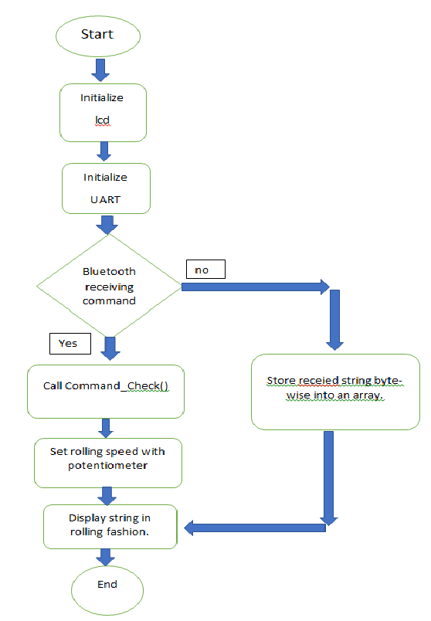

Figure 2.2 Flowchart

**CHAPTER 3**

**SYSTEM DESIGN**

In this chapter the component selection for the project is clearly specified. The selection of the component and their justification is also provided in this chapter.

**3.1 Design of Blocks**

**3.1.1 Selection of microcontroller**

Various microcontroller were compared based on some parameters as given below in following table.

|  |  |  |  |
| --- | --- | --- | --- |
| **Parameters** | **PIC** | **ARM** | **Atmega328** |
| 1. **GPIO** | 5 | 2 | **2** |
| 1. **RAM** | 2kbyte | 40kbytes | **2kbyte** |
| 1. **ROM** | 32kbytes | 512kbytes | **1kbytes** |
| 1. **Frequency** | 48Mhz | 60Mhz | **16Mhz** |
| 1. **ADC** | 13ch-10bits | 2-14ch-10bits | **1-6ch-10bits** |
| 1. **Timers** | 1-8bit.3-16 bits | 2-32 bits | **3-32bits** |
| 1. **UART** | 1 | 2 | **1** |

**Table 3.1 comparison of different microcontroller**

**Microcontroller Atmega328**

The Arduino Uno is a microcontroller board based on the ATmega328. It has 20 digital input/output pins (of which 6 can be used as PWM outputs and 6 can be used as analog inputs), a 16 MHz resonator, a USB connection, a power jack, an in-circuit system programming (ICSP) header, and a reset button. It contains everything needed to support the microcontroller; simply connect it to a computer (or appropriate [wall power adapter](https://www.pololu.com/product/1459)) with a USB cable or power it with a [AC-to-DC adapter](https://www.pololu.com/product/1463) or battery to get started.

The Uno differs from all preceding boards in that it does not use the FTDI USB-to-serial driver chip. Instead, it features an ATmega16U2 programmed as a USB-to-serial converter. This auxiliary microcontroller has its own USB bootloader, which allows advanced users to reprogram it.

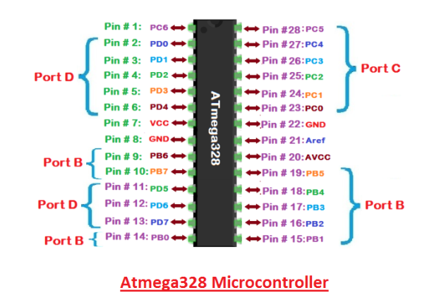

**Figure 3.1 Atmega microcontroller**

Features of Arduino Uno

* Microcontroller: ATmega328
* Operating Voltage: 5V
* Input Voltage (recommended): 7-12V
* Input Voltage (limits): 6-20V
* Digital I/O Pins: 14 (of which 6 provide PWM output)
* Analog Input Pins: 6
* DC Current per I/O Pin: 40 mA
* DC Current for 3.3V Pin: 50 mA
* Flash Memory: 32 KB of which 0.5 KB used by bootloader
* SRAM: 2 KB (ATmega328)
* EEPROM: 1 KB (ATmega328)
* Clock Speed: 16 MHz

**3.1.2 Selection of led matrix driver**

|  |  |  |
| --- | --- | --- |
| **Parameter** | **Maxim MAX7219** | **74HC595** |
| **Name** | **8-digit LED display driver** | **8-bit Serial input parallel output shift register** |
| **No. of pins** | **24** | **16** |
| **Operating voltage** | **-0.3V to 6V** | **2.0V to 6.0V** |
| **Drive Source current** | **40mA** | **75mA** |
| **Frequency** | **10Mhz** | **100Mhz** |

**Table 3.2 comparison of max3719 and 74HC595**

**MAX7219**

* The MAX7219/MAX7221 are compact, serial input/output common-cathode display drivers that interface microprocessors (µPs) to 7-segment numeric LED displays of up to 8 digits, bar-graph displays, or 64 individual LEDs.
* Included on-chip are a BCD code-B decoder, multiplex scan circuitry, segment and digit drivers, and an 8x8 static RAM that stores each digit.
* Only one external resistor is required to set the segment current for all LEDs.
* The devices include a 150µA low-power shutdown mode, analog and digital brightness control, a scan-limit register that allows the user to display from 1 to 8 digits, and a test mode that forces all LEDs on.

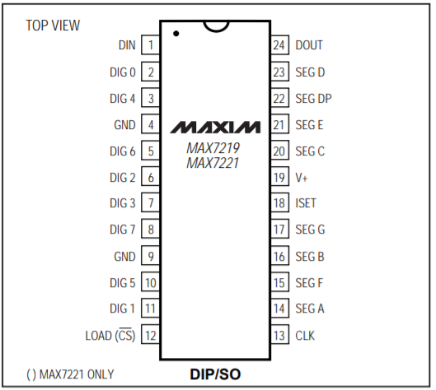

**Figure 3.2 MAX7219 pinouts**

The 64 LEDs are driven by 16 output pins of the IC. The question now is how is that possible.  Well the maximum number of LEDs light up at the same time is actually eight. The LEDs are arranged as 8×8 set of rows and columns. So the MAX7219 activates each column for a very short period of time and at the same time it also drives each row. So by rapidly switching through the columns and rows the human eye will only notice a continuous light.

The following table from the datasheet of the IC shows the value of the resistor that we should use according to the forward voltage drop of our LEDs.

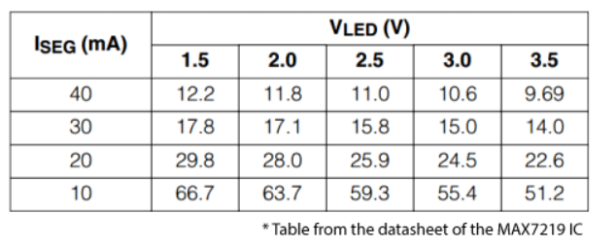

**Table 3.3 selection of Iset Resistor**

Connection of LED matrix with MAX7219

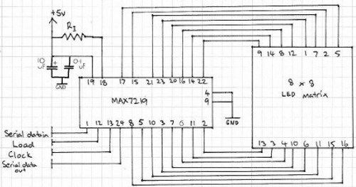

**Figure 3.3 Connection of MAX7219 and 8x8 matrix**

**3.1.3 Selection of LEDs**

The color of the LED used for the LED Matrix Display is red. The reason we have selected this LED is because it is known that human eyes are least sensitive to red color. In other words, shades of red light are least sensitive to our eyes. This implies that slight variation in the brightness of the red LED lights will mostly go unnoticed by our eyes. This fact is crucial in our product since we require constant brightness of all LEDs. Even though considerable thought and careful designing has been done to maintain constant brightness, it is nevertheless probable that slight error will arise, due to imperfect and non-uniform electronic components, which is inevitable. Therefore, red lights provide the perfect solution for this problem.

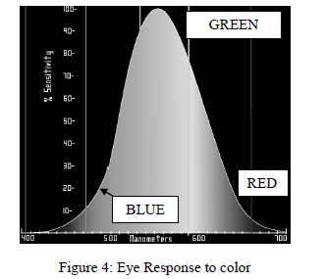

Figure 3.4 illustrates that RED and Blue lights are least sensitive to human eyes. While this fact is advantageous to our product as discussed earlier, it however implies that a red LED must have a much stronger efficiency than a green one to be visible at the same intensity. It means that sensitivity to wavelength and sensitivity to intensity are different. For a green LED and red LED to be of equal intensity, the latter’s efficiency should be greater or in other words power transfer should be greater. Considering this fact it is ensured that optimum intensity of the red LEDs used in the product has been maintained under safe limits. Generally Red LEDs are constructed using GaAsP and their threshold voltage is usually 1.3 V.

**LED Matrix Configuration:**

The dimension of LED Matrix chosen for our project is 8×8. To reduce this difficulty the configuration of the LED matrix is done in following way:

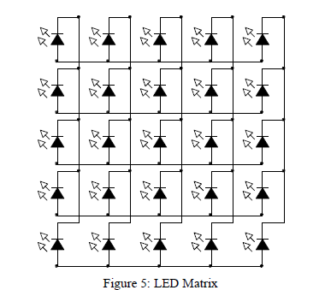

The configuration shown in figure 3.5 allows reduction of points to be controlled for the LED Matrix Display. Instead of controlling each individual LED, the configuration allows us to control entire row and column at any instance. In the configuration, the anodes of the LEDs are connected along a row and the cathodes are connected along a column. This allows control of an individual LED in any instance. For example, if we wish to control a LED at position 2×2, we can do it by controlling voltage supply at 2nd row and ground supply at 2nd column. In this way any LED in the matrix can be controlled. In case of 5×5 LED matrix, this configuration reduces the control points to 10 from 25.

**3.1.4 Selection for Speed Control**

|  |  |  |
| --- | --- | --- |
| **Parameter** | **Potentiometer** | **Rheostat** |
| **No. of terminal** | **3** | **2** |
| **Operation parameter** | **Voltage** | **current** |
| **Usage** | **Can be used as rheostat** | **Can’t use as potentiometer** |

**Table 3.4 Comparison of Potentiometer and Rheostat**

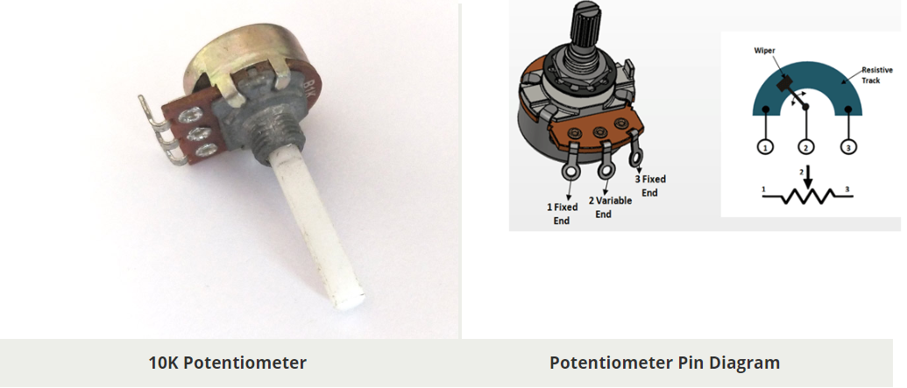

**Figure 3.6 : Potentiometer and its symbol**

**Potentiometer**

A potentiometer, also called as POT, is a 3-terminal variable resistor and is used to adjust the resistance in a circuit. the working of potentiometer is the same as that of a variable resistor. The construction is also the same. It has a resistive element as the track and a sliding contact called the wiper. The wiper is connected with the help of another sliding contact to another terminal. The position of the wiper depends on the type of POT used. For a panel POT, the wiper is kept in the middle. The resistive element has a terminal on both the ends and can be linear or logarithmic. It is usually made up of carbon or a mixture of ceramic and metal or even graphite.

There is single turn POTs which changes its entire resistance in one rotation. More accurate POTs called multi-turn POTs are also present. They need about 20 to 30 rotations to change the entire resistance. They are much more accurate than the former. Take a look at the symbol of a POT.

**3.1.5 Selection of Bluetooth Module**

|  |  |  |
| --- | --- | --- |
| **Parameter** | **HC-05** | **HC-06** |
| **Firmware** | **Master or slave** | **Only slave** |
| **No. of pins** | **6** | **4** |
| **Switch button** | **Yes** | **No** |
| **Total no. of pins connected** | **34** | **31** |

**Table 3.5 : HC-05 vs. HC-06**

**Specification of the Bluetooth Module**

The boards are based on the EGBT-045MS/EGBT-046S Bluetooth modules which are loaded with SPP firmware for UART communication.

* Radio Chip: CSR BC417
* Memory: External 8Mbit Flash
* Output Power: -4 to +6dbm Class 2
* Sensitivity: -80dbm Typical
* Bit Rate: EDR, up to 3Mbps
* Interface: UART
* Antenna: Built-in
* Dimension: 27W x 13H mm
* Voltage: 3.1 to 4.2VDC
* Current: 40mA max

the EGBT-045MS and EGBT-046S modules have the same hardware and the only difference is the firmware. The different firmware does change the pin outs though.

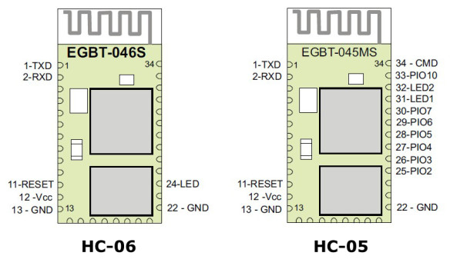

**Figure 3.7: HC05 and HC06**

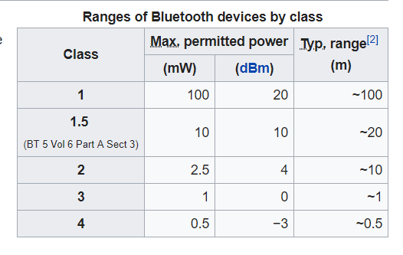

**Table 3.6 ranges of Bluetooth devices**

**3.1.6 LCD 16x2**

LCD modules are vey commonly used in most embedded projects, the reason being its cheap price, availability and programmer friendly. Most of us would have come across these displays in our day to day life, either at PCO’s or calculators. The appearance and the pinouts have already been visualized above now let us get a bit technical.

16×2 LCD is named so because; it has 16 Columns and 2 Rows. There are a lot of combinations available like, 8×1, 8×2, 10×2, 16×1, etc. but the most used one is the 16×2 LCD. So, it will have (16×2=32) 32 characters in total and each character will be made of 5×8 Pixel Dots.

The Command register stores the command instructions given to the LCD. A command is an instruction given to LCD to do a predefined task like initializing it, clearing its screen, setting the cursor position, controlling display etc. The data register stores the data to be displayed on the LCD. The data is the ASCII value of the character to be displayed on the LCD.

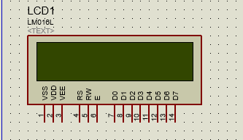

**Figure 3.8: LCD with pinouts**

**3.2 Selection of components and justification:**

|  |  |  |
| --- | --- | --- |
| **Sr no** | **Component Name** | **Justification of Selection** |
| 1 | ARDUINO UNO | * The Atmel 8-bit AVR RISC based microcontroller * Digital I/O pins: 14 of which 6 provide PWM * Analog input Pins: 6 * DC Current I/O pins : 40mA * 16 Mhz crystal Oscillator |
| 2. | MAX7219 | * 10MHz Serial Interface * Individual LED Segment Control * Decode/No-Decode Digit Selection * 150µA Low-Power Shutdown (Data Retained) * Drive Common-Cathode LED Display * 24-Pin DIP and SO Packages |
| 3. | Led matrix | * Low Current Consumption * High Brightness * Easy to Use * PCB Mounting |
| 4. | Bluetooth | * Memory: External 8Mbit Flash * Output Power: -4 to +6dbm Class 2 * Sensitivity: -80dbm Typical * Current: 40mA max * Interface: UART * Antenna: Built-in |
| 5. | Potentiometer | * Voltage divider circuits. |
| 6. | LCD | * Type: character * Display Format: 16x2 characters * Duty cycle:1/16 * +5V power supply |

**Table 3.7 Selection of components and justification**

**CHAPTER 4**

**IMPLEMENTATION, TESTING AND DEBUGGING**

**4.1 LED blinking using 74HC595**

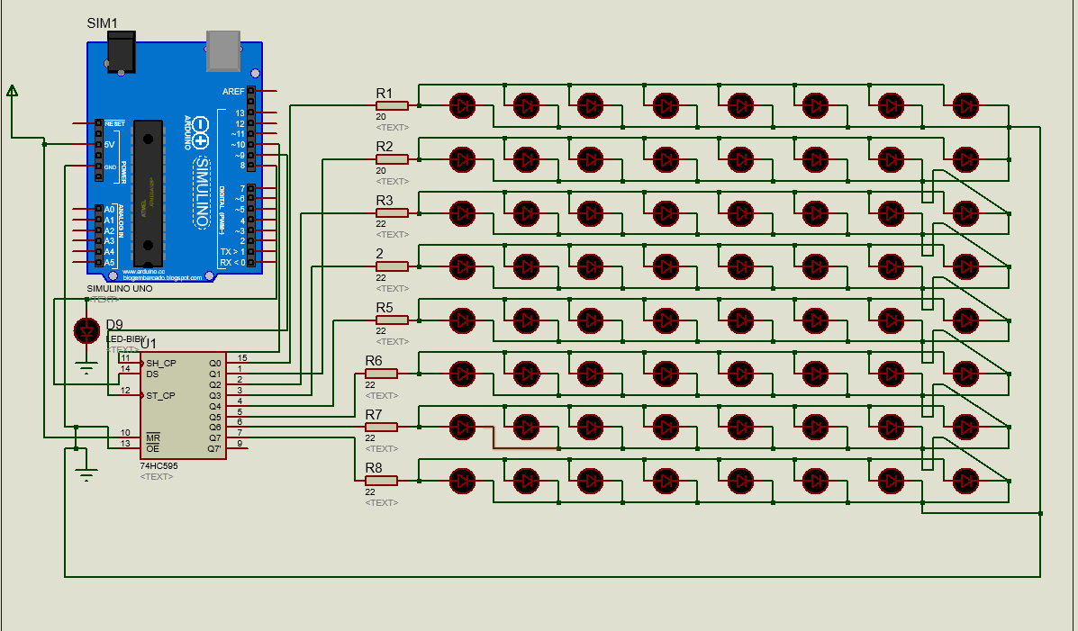

**Figure 4.1 : 8x8 matrix with 74HC595**

Result:

* All the LEDs of a row glow all together which is not expected since it was coded to glow one by one.
* The Resistance required for each row is 330 ohm in proteus.

Conclusion:

* 74HC595 clock speed is much fast for sequence to recognize by naked eyes. Hence another driver IC must be chosen.
* For 48 leds to glow the resistance required will certainly reduce to few double digit ohms.

**4.2 8x8 led matrix with MAX7219**

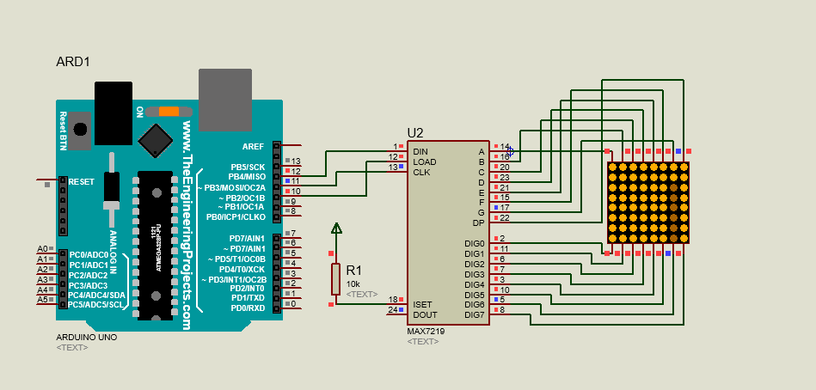

**Figure 4.2 : 8x8 matrix with MAX7219**

Result:

* Using max particular LED was able to glow.
* The data required to be loaded in max is 8bit in size.

Conclusion:

* The character to be show on led matrix could easily done using MAX7219 as compared to 74HC595.

**4.3 PCB Design Layout**

**4.3.1 Arduino Controller Board**

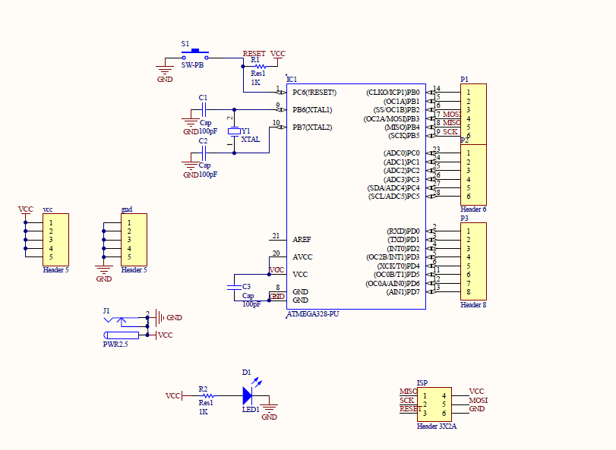

**Figure 4.3: Schematic of microcontroller**

**Stage A:** Getting PCB of Size (10x10)

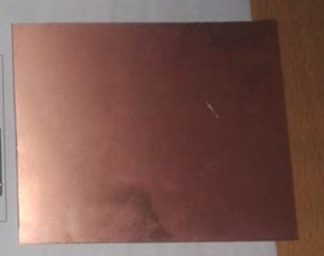

**Figure 4.4 : PCB copper plated board**

Get a required size of PCB on which all the components can placed with suitable distance.

**Stage B:** Layout Designing

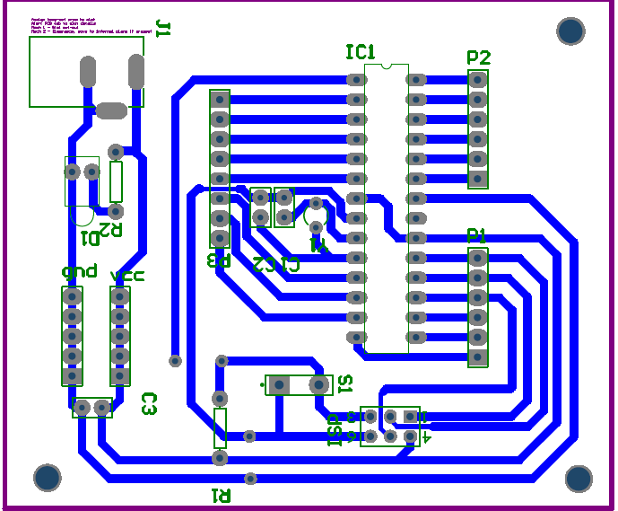

**Figure 4.5: PCB layout of microcontroller**

There are lot of paid and free softwares available for this purpose, some open source software are Cadsoft Eagle, Fritzing, PCBWizard etc. Here we are uisng Cadsoft Eagle software of PCB designing. After making layout we need to take the printout of mirror image of the PCB layout. Print should be taken on Glossy paper/Photo Paper using the Laser Printer.

**Stage C:** Layout placed on PCB

place this copper clad by the side of printed side of photo paper, and fold the paper.

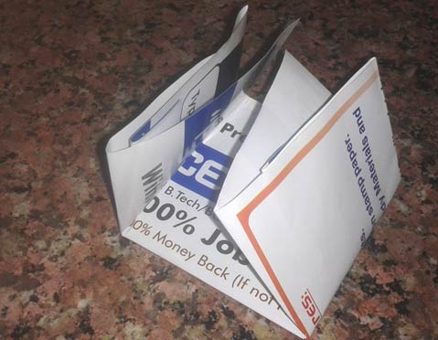

**Figure 4.6: layout on PCB**

Now take a hot iron and start ironing slowly for 5-10 minutes or tightly press the hot iron for some time. Heating the paper will transfer the ink to the copper board. Now allow copper plate to be cool down, and open the folded paper. If paper gets stuck to the plate, use warm water to remove the paper properly.

**Stage D:** Etching

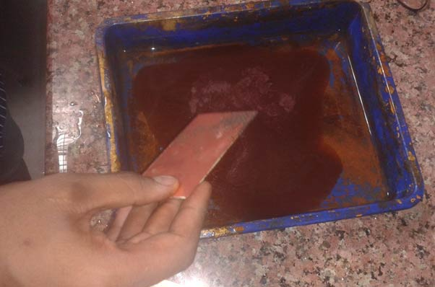

**Figure 4.7:Etching process**

For this we will make Ferric chloride solution (FECL3), by adding 2-3 tea spoon of Ferric chloride in some water. This solution is called Etching Solution. Put the PCB in this solution for approx. half an hour. Now Ferric chloride will react and remove the exposed copper and won’t react with the masked copper under the Black lines. And we get copper track as per our PCB layout.

Now rub the PCB with the steel wool or fine sand paper to remove the black ink, or you can use thinner (Acetone) on a piece of cotton to remove Black ink. Now you can see the shiny copper tracks clearly as per our printer PCB layout.

**Stage E:**  Drilling

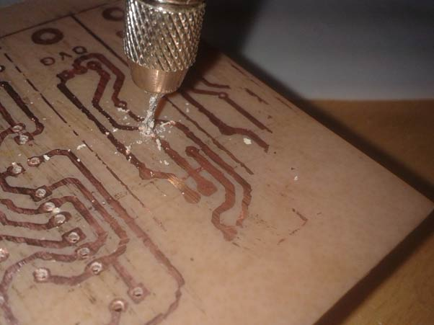

**Figure 4.8: Drilling Pricess**

Drilling is the process of creating a hole as per layout designing and requirement of component placing. This task is done with help of drilling machine which having different size of leads. We will use 0.1mm lead for drilling purpose.

**Stage F:**  Component Placing and soldering:

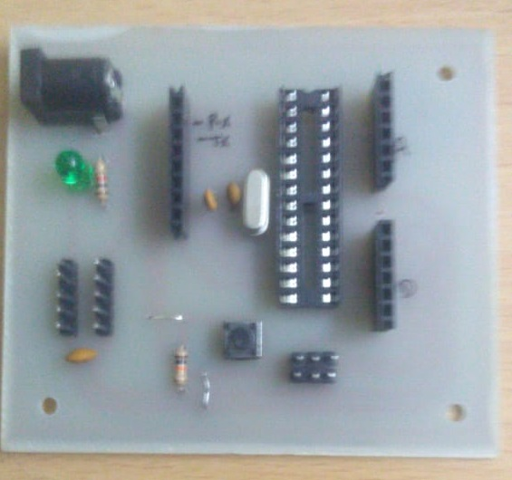

**Figure 4.9 : Component placing and soldering**

Component placement is an electronic manufacturing process that places components precisely on PCB to create electrical interconnections between functional components and the interconnecting circiutary in the PCB leads. The next step after component placing is soldering. It is act of using a solder by melting it between two material in order to attach them together.

**4.3.2 48x8 LED Matrix**

Similar process is followed for designing 48x8 LED matrix.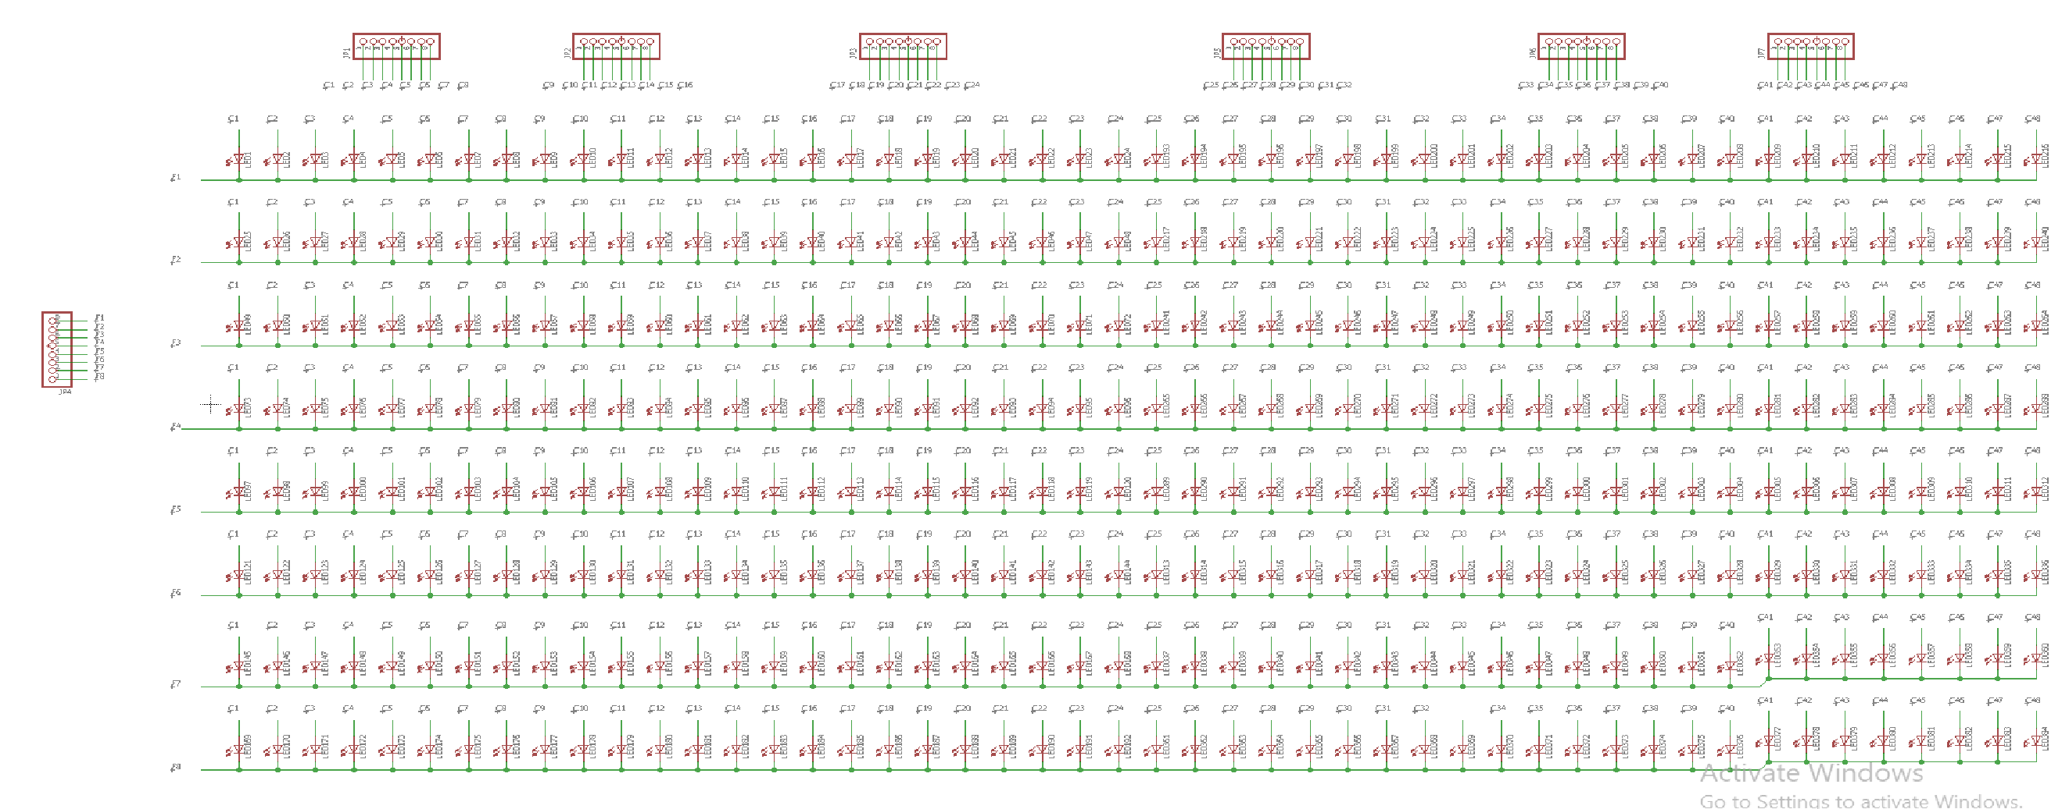

**Figure 4.10: Led Matrix Schematic**

Schematic for the Led matrix was built using software Cadsoft Eagle. After making layout we need to take the printout of  mirror image of the PCB layout. After the PCB printing and etching process components were mounted and soldered.

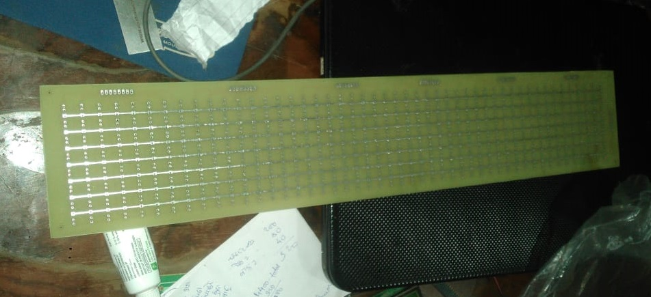

**Figure 4.11 : double side PCB for LED Matrix**

**4.3.3 LED Matrix Driver**

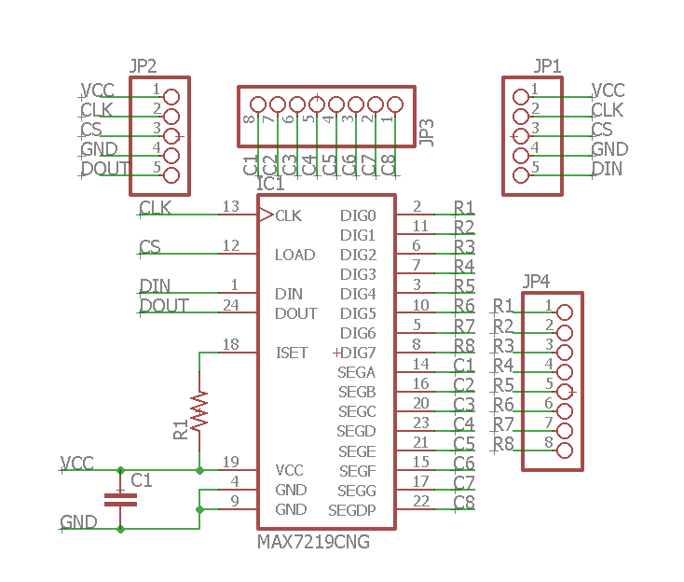

**Figure 4.12: Driver Circuit Schematic**

Schematic for the Driver circuit was built using software Cadsoft Eagle. After making layout we need to take the printout of mirror image of the PCB layout. After the PCB printing and etching process components were mounted and soldered.

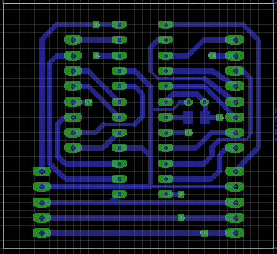

**Figure 4.13: PCB design of driver**

**4.4 Testing and Troubleshooting**

* Dry soldering: Connectivity was not proper in between two components.
* Desoldering: This is done for component replacement purpose.
* Testing: Testing is the process in which whole circuit is divided in subpart and test the connectivity between them.
* Avoided parallel connection to component to reduce circuit complexity.
* Swapped traditional Components for better layout designing, without jumper connection.

**CHAPTER 5**

**Results and discussion**

Hence, in earlier chapters we saw the implementation, testing and debugging of LED matrix. From implemented project we are able to operate the scrolling of the text messages through a application using a Bluetooth device HC-05.

**5.1 Scrolling text in English**

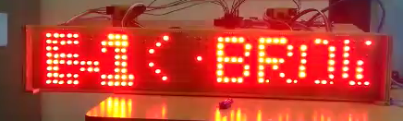

**Figure 5.1: Scrolling text in English**

In the above figure, The E-1 part is static text whereas on the right side scrolling text is seen. The complete text seen during this result was “THE QUICK BROWN FOX JUMPED OVER THE LAZY DOG the quick brown fox jumped over the lazy dog”

**5.2 Static text in Hindi**

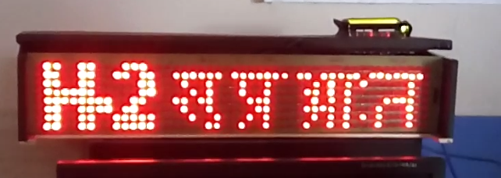

**Figure 5.2 : Static text in hindi**

In the above figure, H-2 tag had string received from application as “suphrabhat” (सुप्रभात ). From the application total 4 distinct string can be displayed.

**5.3 Scrolling text in German**

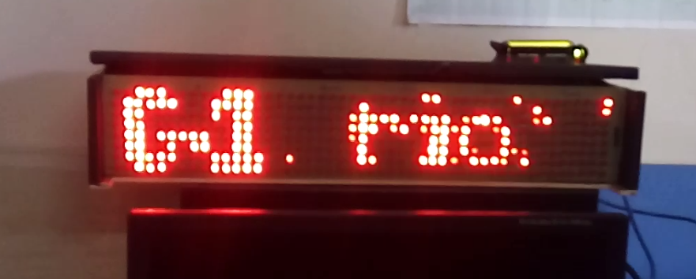

**Figure 5.3: German rolling text**

In the above figure, An simple German proverb was displayed. The statement in English means, “troubled water, fisherman’s gain”.

**5.4 Implementing Number and special characters.**

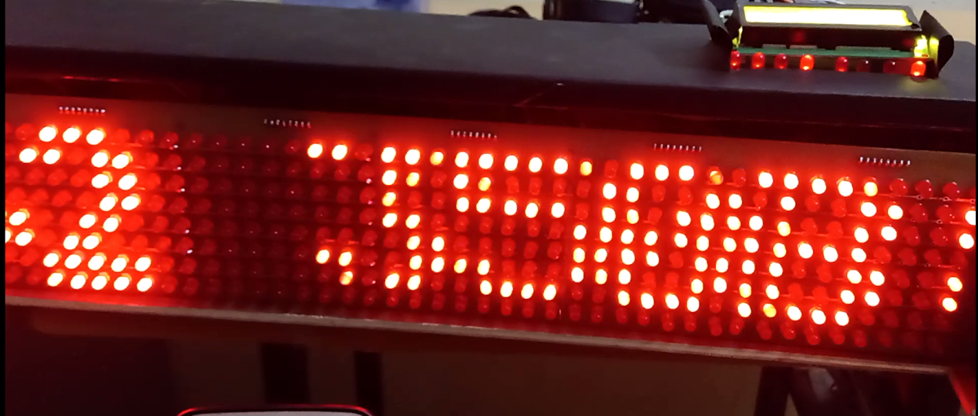

**Figure 5.4: Specical character and numbers display**

In the above figure the project was upgraded to not only display characters but also numbers along with special characters from the standard ASCII table[5].

**5.5 Speed Control display on LCD**

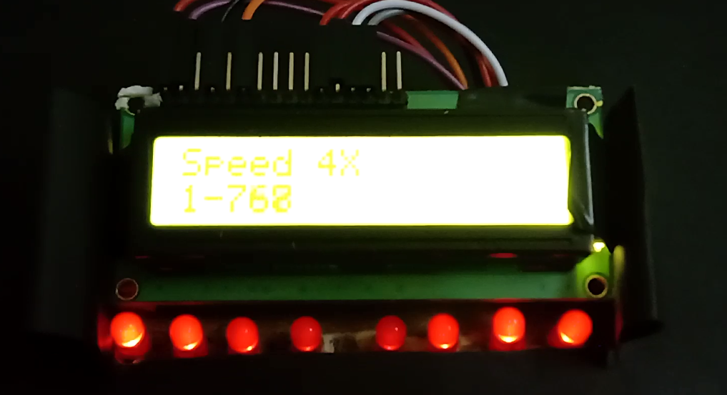

**Figure 5.5: Speed Control display**

In this figure, shows the display for the speed potentiometer. When the pot was slowly moved to higher value, the corresponding speed was established and displayed on LCD. There are total 4 point of speed change.

**CHAPTER 6**

**Conclusion and Future Scope**

**6.1 Conclusion**

Even today public institutes use the conventional method of displaying notices. In this world of digitalization, there’s an immense need to save paper and easy handling of displaying short messages. Through our project we were not only able to display rolling messages but also through the application we built, user can display short messages one after the other in more than 1 languages.

Almost every project is subjected to change. The system and the architecture of the propose system is compatible one, so addition of new modules can be done without much difficulty. Since this module has its unique properties it can be extended further to make this system a complete one with extended features.

The product is implemented and tested and were found to be error free. Hence, the purposed system is very efficient in displaying messages in any college activities or in public place required.

**6.2 Future Scope**

The existing system developed till date works reliably with all the objectives that are predefined at the start of this project. The system can be further enhanced with respect to the following parameters such as:

* User will be able to type and send messages.
* User will be able to send messages through voice.
* The displayed messages will be spoken as audio.
* Attendance display using face- recognition.

**CHAPTER 7**

**Bill of Material**

|  |  |  |  |  |
| --- | --- | --- | --- | --- |
| Sr. No | Component Name | Quantity | Per Unit Cost | Cost (Rupees) |
| 1 | ATMEGA 328 PU | 1 | 300 | 300 |
| 2 | LEDS | 500 | 0.8 | 400 |
| 3 | PERF BOARD | 2 | 50 | 100 |
| 4 | SOLDER WIRE | 1 | 80 | 80 |
| 5 | WIRE | 15 | 5 | 75 |
| 6 | PINHEADS | 4 | 20 | 81 |
| 7 | MAX 7219 | 6 | 180 | 1080 |
| 8 | Capacitor 22uF | 2 | 10 | 20 |
| 9 | Capacitor 10uF | 2 | 15 | 30 |
| 10 | Capacitor disc | 3 | 10 | 30 |
| 11 | JUMPER WIRES | 2 | 80 | 160 |
| 12 | ATMEGA BASE | 1 | 10 | 10 |
| 13 | RESISTOR 150 Ohm | 4 | 1 | 4 |
| 15 | CRYSTAL OSCILLATOR | 1 | 30 | 30 |
| 16 | LM 7805 | 2 | 30 | 60 |
| 17 | PCB Designing of LED MATRIX | 1 | 1500 | 1500 |
| 18 | PCB Designing of MAX Controller | 6 | 180 | 1080 |
| 19 | PCB Designing of Arduino | 1 | 384 | 384 |
|  |  |  | **TOTAL COST** | **5624** |

**APPENDIX**

**REFERENCES**

[1] Adamu Murtala Zungeru1, Gbenga Daniel Obikoya2, Ochi Fortunatus Uche3, Taidi Eli4 International Journal of Computational Science, Information Technology and Control Engineering (IJCSITCE) Vol.1, No.3, October 2014.

[2] Anuradha Mujumdar, Vaishali Niranjane, Deepika Sagne, Scrolling Led Display Using Wireless Transmission, 2014 IJEDR | Volume 2, Issue 1 | ISSN: 2321-9939

[3] A survey of light emitting diode(LED) display board. Indian Journal of Science and Technology, Vol 7(2), 185–188, February 2014.

[4] Htet Htet Thit San, Chaw Myat Nwe and Hla Myo Tun, Implementation of PIC Based LED Displays, International Journal of Electronics and Computer Science Engineering, ISSN- 2277-1956.

[5] M. David. “ASCII standard “ Internet: <http://www.asciitable.com/>, dec. 25, 2011 [Nov. 25, 2010].